Identifying Variables

- A scientific investigation has 3 kinds of variables:
  - Independent variable – what you change on purpose in the experiment.
  - Dependent variable – what you measure or observe in the experiment.
  - Controlled variables – all the things you keep the same.

In the following scenarios, identify the independent variable, the dependent variable, and controlled variables.

- How does the amount of soap affect the number of bubbles in the water?
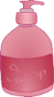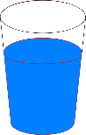 |  | 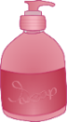 |  | 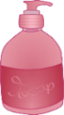
2 drops of soap | 4 drops of soap |  | 6 drops of soap
Independent Variable |  | Dependent Variable |  | Controlled Variables

- How does the colour of a candy affect how quickly it dissolves in water?
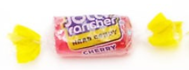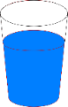 |  | 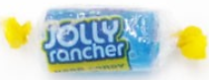 |  | 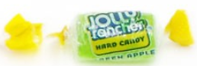
Pink candy |  | Blue candy |  | Green candy
Independent Variable | Dependent Variable |  | Controlled Variables

- How does the type of fertillizer affect how quickly a plant grows?
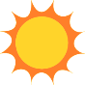  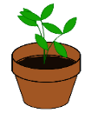 | 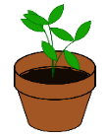 | 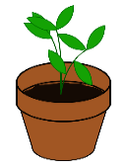
fertillizer: Safco | fertillizer: Agrium | fertillizer: Miracle-Gro
Independent Variable | Dependent Variable | Controlled Variables

- How does the type of food affect the weight of a dog?
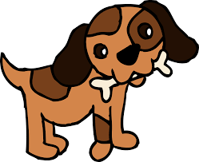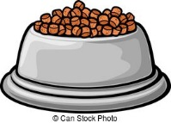
Food: Iams |  | Food: Purina |  | Food: Natural Choice
Independent Variable | Dependent Variable |  | Controlled Variables
- How does the amount of sugar affect the taste of coffee?
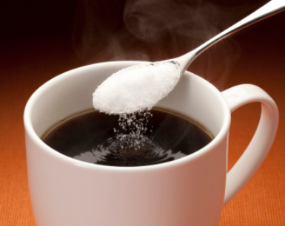
1 teaspoon of sugar |  | 2 teaspoons of sugar |  | 3 teaspoons of sugar
Independent Variable | Dependent Variable |  | Controlled Variables

- How does the temperature of water affect how quickly an egg boils?
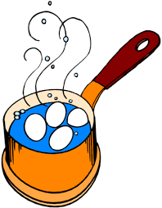
temperature of water = 75^{O}C | temperature of water = 100^{O}C | temperature of water = 150^{O}C
Independent Variable | Dependent Variable | Controlled Variables

- How does the angle a ball is thrown affect how far the ball will go?
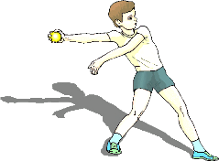
angle of 100^{O} | angle of 130^{O} |  | angle of 150^{O}
Independent Variable |  | Dependent Variable |  | Controlled Variables

- How does the amount of water affect how many lemons grow on a tree?
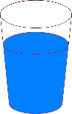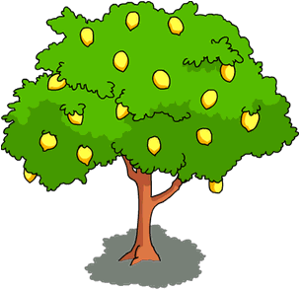
Independent Variable |  | Dependent Variable |  | Controlled Variables

- How does the temperature in a classroom affect students’ concentration?
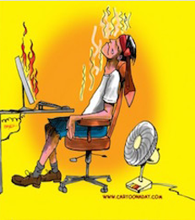 | 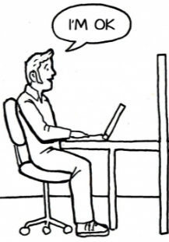 | 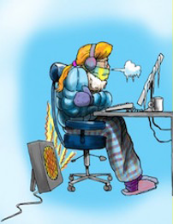
temperature = hot | temperature = average | temperature = cold
Independent Variable | Dependent Variable | Controlled Variables

- How does the number of insects in an area affect how many bats there are?
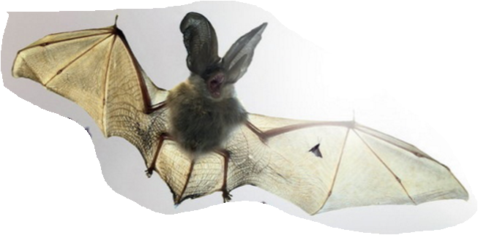 | 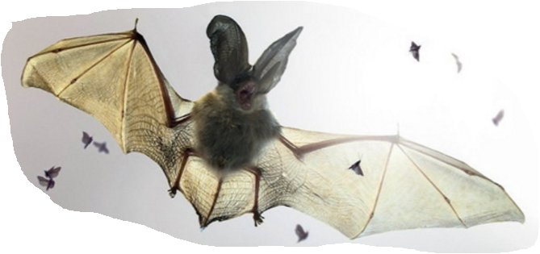 |  |  | 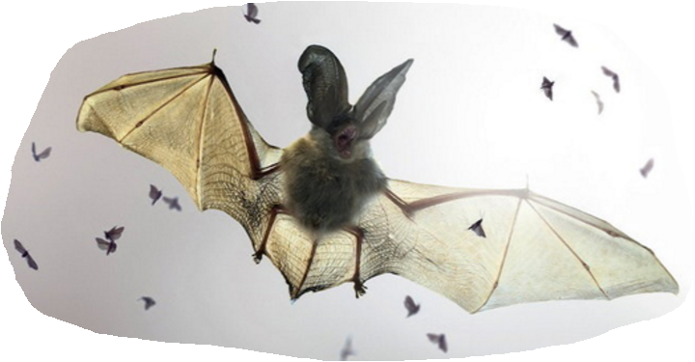
no insects | a few insects |  |  | a lot of insects
Independent Variable |  | Dependent Variable | Controlled Variables

- How does the amount of rain affect how many flowers grow?
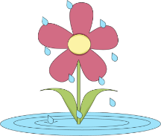
no rain | some rain | a lot of rain
Independent Variable | Dependent Variable | Controlled Variables

- How does the height you drop a ball from affect how high it will bounce?
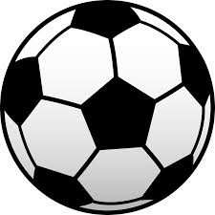
drop from 1 meter |  | drop from 2 meters |  | drop from 3 meters
Independent Variable | Dependent Variable |  | Controlled Variables

Answers

- How does the amount of soap affect the number of bubbles in the water?
2 drops of soap | 4 drops of soap |  | 6 drops of soap
Independent Variable |  | Dependent Variable |  | Controlled Variables
# of drops of soap |  | # of bubbles in the water |  | same type of water  same quantity of water  same temperature  same type of soap  etc.

- How does the colour of a candy affect how quickly it dissolves in water?
Pink candy |  | Blue candy |  | Green candy
Independent Variable | Dependent Variable |  | Controlled Variables
colour of the candy | time it takes to dissolve |  | same type of water  same quantity of water  same temperature  same type of candy  etc.

- How does the type of fertillizer affect the height a plant grows?
fertillizer: Safco | fertillizer: Agrium | fertillizer: Miracle-Gro
Independent Variable | Dependent Variable | Controlled Variables
type of fertilizer | height of the plant | same quantity of sun  same quantity of water  same quantity of fertilizer  same type of soil  etc.

- How does the type of food affect the weight of a dog?
Food: Iams |  | Food: Purina |  | Food: Natural Choice
Independent Variable | Dependent Variable |  | Controlled Variables
type of food | weight of the dog |  | same dog  same quantity of food  eats at the same time  same type and quantity of exercise  etc.
- How does the amount of sugar affect the taste of coffee?
1 teaspoon of sugar |  | 2 teaspoons of sugar |  | 3 teaspoons of sugar
Independent Variable | Dependent Variable |  | Controlled Variables
quantity of sugar | taste of the coffee |  | same type of coffee  same type of sugar  same quantity of coffee  etc.

- How does the temperature of water affect how quickly an egg boils?
temperature of water = 75^{O}C | temperature of water = 100^{O}C | temperature of water = 150^{O}C
Independent Variable | Dependent Variable | Controlled Variables
temperature of water | time it takes for the egg to boil | same type of egg  same pot  same type of water  same quantity of water  etc.

- How does the angle a ball is thrown affect how far the ball will go?
angle of 100^{O} | angle of 130^{O} |  | angle of 150^{O}
Independent Variable |  | Dependent Variable |  | Controlled Variables
angle of the throw |  | distance of the ball |  | same thrower  same ball  same hand to throw with  etc.

- How does the amount of water affect how many lemons grow on a tree?
Independent Variable |  | Dependent Variable |  | Controlled Variables
quantity of water |  | number of lemons that grow |  | same quantity of sunlight  same type of tree  same soil  etc.

- How does the temperature in a classroom affect students’ concentration?
temperature = hot | temperature = average | temperature = cold
Independent Variable | Dependent Variable | Controlled Variables
temperature of the room | concentration of students | same room  same students  same activity  etc.

- How does the number of insects in an area affect how many bats there are?
no insects | a few insects |  |  | a lot of insects
Independent Variable |  | Dependent Variable | Controlled Variables
# of insects |  | # of bats | same place  same type of insects  same time of day  etc.

- How does the amount of rain affect how many flowers grow?
no rain | some rain | a lot of rain
Independent Variable | Dependent Variable | Controlled Variables
quantity of rain | # of flowers | same type of flowers  same place  same soil  etc.

- How does the height you drop a ball from affect how high it will bounce?
drop from 1 meter |  | drop from 2 meters |  | drop from 3 meters
Independent Variable | Dependent Variable |  | Controlled Variables
height of the drop | height of the bounce |  | same ball  same amount of air in the ball  same surface  etc.

